Signal Processing Results — Python-Based Output

Author：GONG SHENG
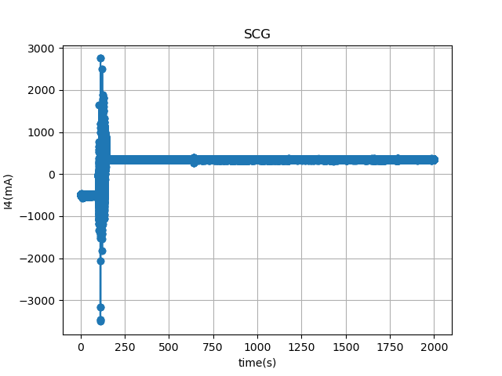
The complete image across the entire time axis is shown below (time axis from t=0 to t=2097.15s, step size of 0.002s, sampling frequency of 500Hz)：
Figure 1 Complete image of the original signal

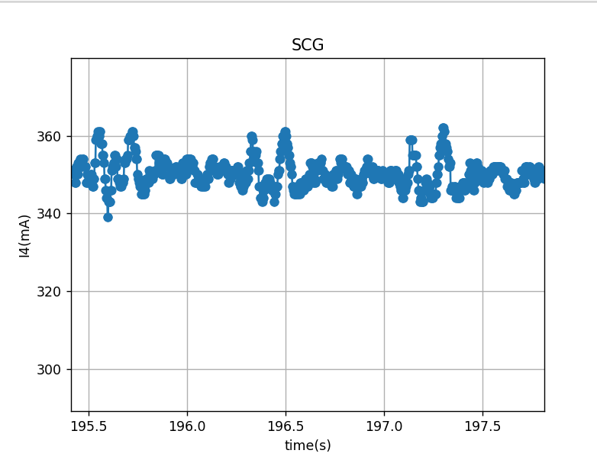
Let's capture a small segment of its signal:
Figure 2 The waveform appears clearer when enlarged.

The signal passes through a Butterworth filter:
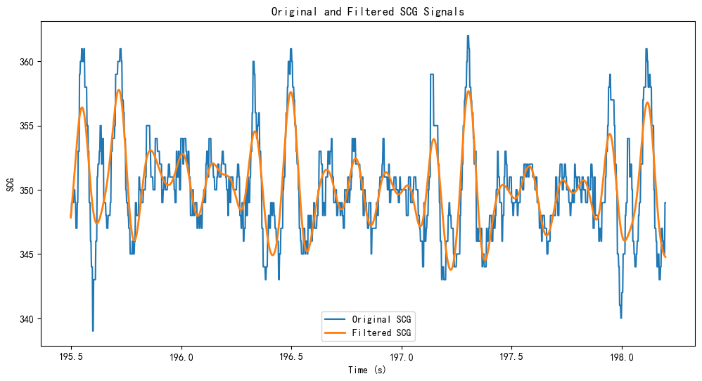
Figure 3 Original signal and filtered SCG signal

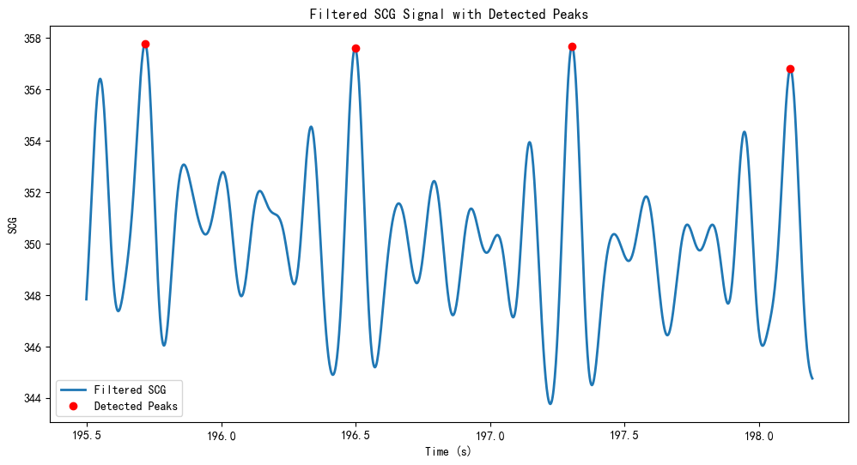
Using the find peaks function for peak detection yields the following image:
Figure 4 Filtered SCG Signal with Detected Peaks

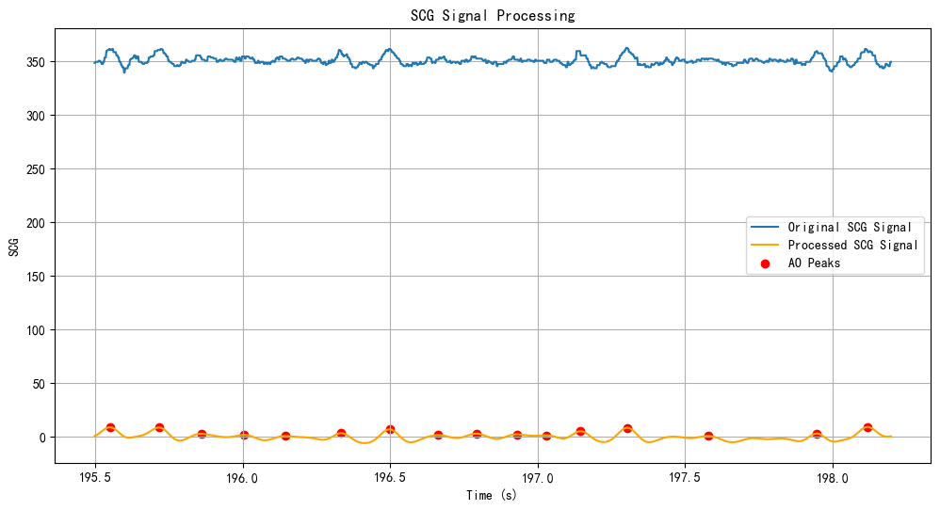
Eliminate baseline drift:
Figure 5 After baseline drift correction

Comparison sheet:
Sheet: peak time points and corresponding peak SCG values
peak time points（s）： | peak SCG values
195.55 | 9.058
195.716 | 8.815
195.86 | 2.869
196.006 | 1.900
196.144 | 0.837
196.334 | 3.574
196.498 | 7.088
196.662 | 1.716
196.792 | 3.104
196.93 | 2.482
197.028 | 1.552
197.146 | 5.372
197.304 | 8.570
197.578 | 0.929
197.946 | 3.151
198.118 | 9.325

